Update from Worcestershire Acute Hospitals NHS Trust regarding Changes to Cancer Pathways as a result of Covid-19
15th April 2020
Changes to cancer pathways as a result of the Covid-19 pandemic are detailed below:

Update from the Colorectal Team regarding 2ww Colorectal Suspected Cancer Pathway:
COVID-19 is already putting significant strain on the NHS trust workload and the situation is expected to worsen over the next few weeks. This is likely to impact significantly on the trusts ability to triage and manage colorectal 2ww referrals for the coming weeks and months.
BSG, JAG (endoscopy) and BSGAR (radiology) have issued urgent advice regarding lower GI investigation.
(https://www.bsg.org.uk/covid-19-advice/endoscopy-activity-and-covid-19-bsg-and-jag-guidance)
This document gives the following Key advice:
- Following the general strategic intent expressed by the UK Government to reduce any non-essential exposure to the COVID-19 virus and to take all reasonable measures to limit its spread, the BSG now recommends that all endoscopy except emergency and essential procedures should stop immediately (see below).
- We recommend that 2WW referrals are risk assessed on a case by case basis before tests such as upper endoscopy, colonoscopy or CT abdomen/pelvis (or, exceptionally, CT colonography) are organised, to prioritise those felt clinically to be at greatest need and to take account of limited availability of facilities, staff and appropriate PPE.

In line with this we propose that:
- ALL colorectal 2ww referrals should be FIT tested by the referring GP PRIOR to referral. The only exception to this will be patients with a palpable rectal mass who will be assessed in clinic prior to any investigation.

- Any 2ww referrals without evidence of FIT testing will be returned to the referrer.

- FIT testing can be requested in the same way as we are currently doing for low risk symptomatic patients.

- Patients who are FIT positive can be referred on the usual form with the FIT result and date documented. These patients will have telephone triage. Following this all patients will be prioritised according to level of FIT result, symptoms and fitness to urgent or deferred investigation. Patients suitable for deferred investigation will be kept on a 2ww pathway and investigated once national and local conditions allow.

- Patients who are FIT negative should not be referred unless there is a very high level of clinical suspicion. If this is the case the referral will be reviewed by a consultant colorectal surgeon before further investigation is requested.

- We would strongly recommend that GPs carefully consider the age and fitness of any patients they are considering for referral. Only patients felt to be fit for subsequent treatment will be candidates for investigation.

- For any queries from primary care regarding appropriateness of referrals please email Mrs D Nicol (Colorectal cancer lead) directly who will respond to all queries within 7 days. deborahnicol@nhs.net

- 2ww referrals already received by the trust but not yet investigated will not be returned but will have FIT testing requested by the nurse triage team prior to any investigation.

Please see the following flowcharts for greater detail.
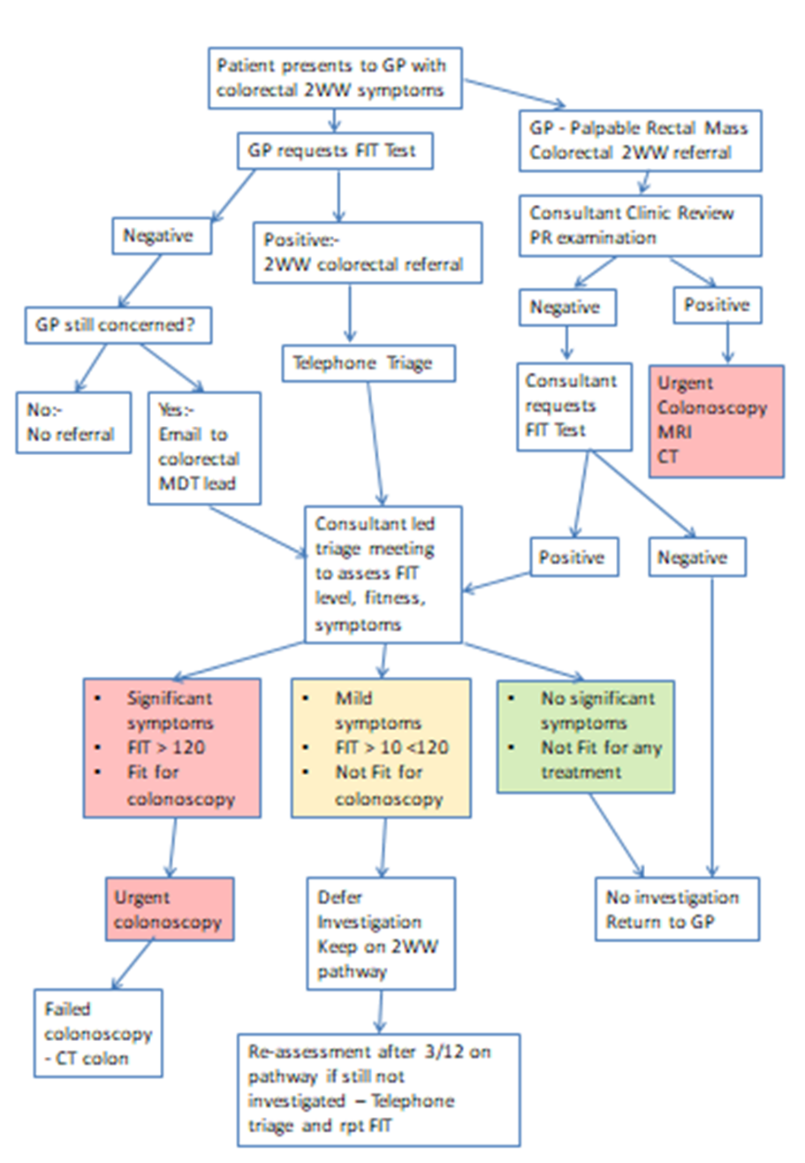
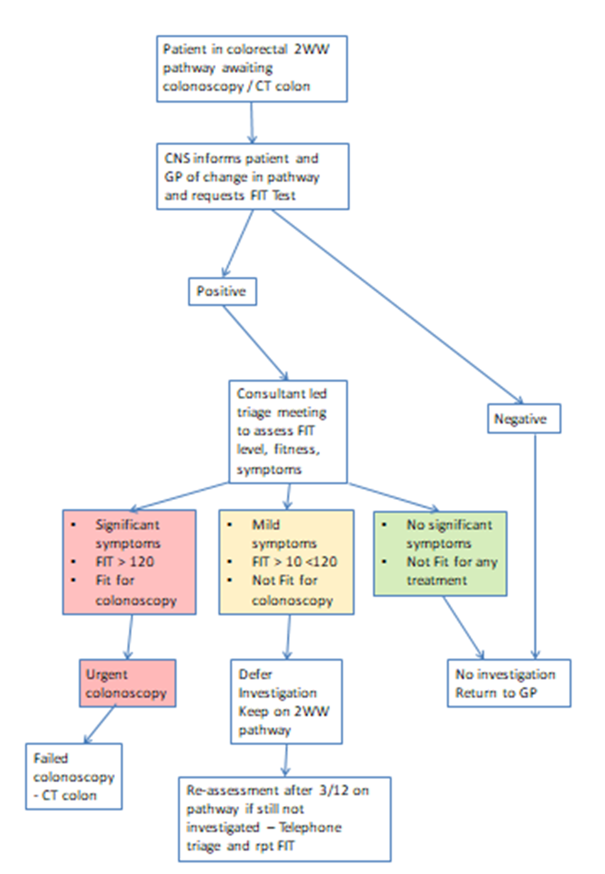

NATIONAL UPDATES (FOR INFORMATION):

Establishment of Midlands Cancer Surgical Hub:
NHSE guidance issued on 7th April 2020 entitled “Clinical guide for the management of essential cancer surgery for adults during the coronavirus pandemic” outlined requirements for local cancer systems to have arrangements in place to maintain essential cancer surgery and ensure the following principles are delivered:
- Equitable treatment of patients with life-threatening cancer who need access to surgical and critical care capacity, in relation to COVID-19 patients;
- In line with national guidelines, balancing the urgency of cancer surgery against the risks of the procedure, particularly the risk of complications and a requirement for intensive care support;
- Equity across local healthcare systems, with capacity maximised in dedicated NHS or independent sector hospitals to allocate patient activity based on the greatest prospects for cure;
- Safety of patients, especially with regard to infection control and access to critical care as required;
- Safety of staff undertaking surgery and other care.

Worcestershire Acute Hospitals NHS Trust and Wye Valley NHS Trust have put arrangements in place locally to secure cancer surgery capacity at ‘clean’ Covid-19 free sites in Herefordshire and Worcestershire.
The Midlands Cancer Alliance is working with 5 main cancer surgery providers across the East and West Midlands to establish a ‘Midlands Cancer Surgical Hub’. This will ensure equitable access to surgical capacity across the footprint for those patients who require it, particularly time-critical surgery, complex surgery or surgery that requires access to ITU/HDU facilities post operatively. Referrals to the Midlands Cancer Surgical Hub will be prioritised on the basis of clinical need and the level of risk, both patient and service-related, after which the referral will be matched with appropriate surgical specialisms and capacity across the cancer system.
Further information can be found at: https://www.england.nhs.uk/coronavirus/wp-content/uploads/sites/52/2020/04/C0239-Specialty-guide-Essential-Cancer-surgery-and-coronavirus-v1-70420.pdf
Cervical Screening:
The current guidance around cervical screening is attached. We are not aware of any updates to the current position as outlined in the letter attached dated 24th March 2020. A complete set of cervical screening guidance is however expected to be released within the next few days, and this will be circulated to all practices once available.

